AI Engineering – 4 weeks
Build, train, fine-tune, and deploy AI models and AI-powered applications

AI Engineering – Week 1
Day – 1: Introduction to Artificial Intelligence (AI):

Learning Objectives
By the end of this session, students will be able to:
- Define Artificial Intelligence and explain its importance.
- Understand how AI is used in everyday life.
- Differentiate between Narrow AI, General AI, and Super AI.
- Identify real-world AI applications.
- Analyze how AI systems learn and make decisions.



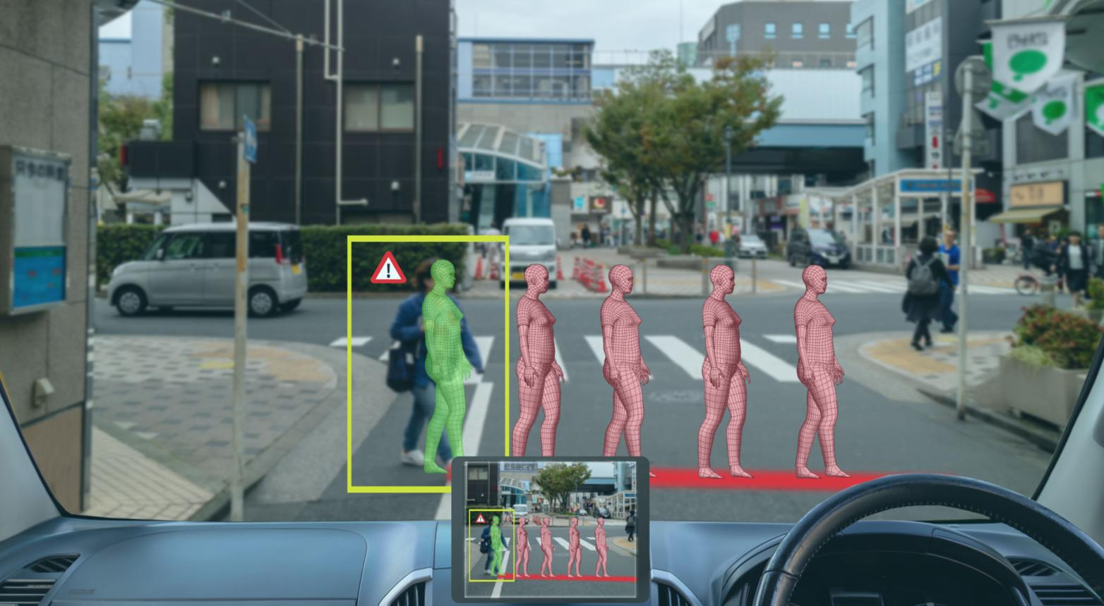

1. What is Artificial Intelligence?
Artificial Intelligence (AI) is a branch of computer science that focuses on creating machines and software capable of performing tasks that normally require human intelligence. These tasks include learning from experience, understanding language, recognizing images, making decisions, solving problems, and even generating creative content.
Traditionally, computers only followed instructions written by programmers. If a programmer forgot to include a rule, the computer would fail. AI changes this approach by allowing systems to learn patterns from data and improve their performance over time without being explicitly programmed for every possible situation.
Think about a child learning to identify cats and dogs. Instead of memorizing a list of rules, the child observes many examples and gradually learns the differences. AI systems learn in a similar way by analyzing large amounts of data and identifying patterns.

Example
Suppose you want a computer to identify whether an image contains a cat.
Traditional Programming:
- Write rules such as:
  - Has whiskers
  - Has four legs
  - Has pointed ears
This approach becomes difficult because every cat looks different.
Artificial Intelligence:
- Show the computer thousands of cat images and non-cat images.
- The AI model automatically learns the patterns that distinguish cats from other objects.
This ability to learn from examples is one of the most important characteristics of AI.

2. Why is AI Important?
AI is transforming almost every industry because it can process huge amounts of information much faster than humans.
Organizations use AI to:
- Reduce manual work
- Improve decision making
- Increase productivity
- Enhance customer experiences
- Discover insights from large datasets
- Automate repetitive tasks
Today, AI powers many technologies that people use every day, often without realizing it.

Example
When you search for a product online, AI analyzes your behavior and recommends similar products that you may want to purchase.
When you watch videos on YouTube, AI predicts which videos you are most likely to enjoy based on your viewing history.

3. Applications of Artificial Intelligence

3.1 AI Assistants and Chatbots



5
AI assistants such as ChatGPT can understand natural language, answer questions, generate code, write articles, summarize documents, and assist users in various tasks.

Example
A student asks:
"Explain machine learning in simple terms."
The AI understands the request and generates a detailed explanation instantly.

Industries Using AI Assistants
- Education
- Customer Support
- Software Development
- Healthcare
- Business Operations

3.2 Self-Driving Cars
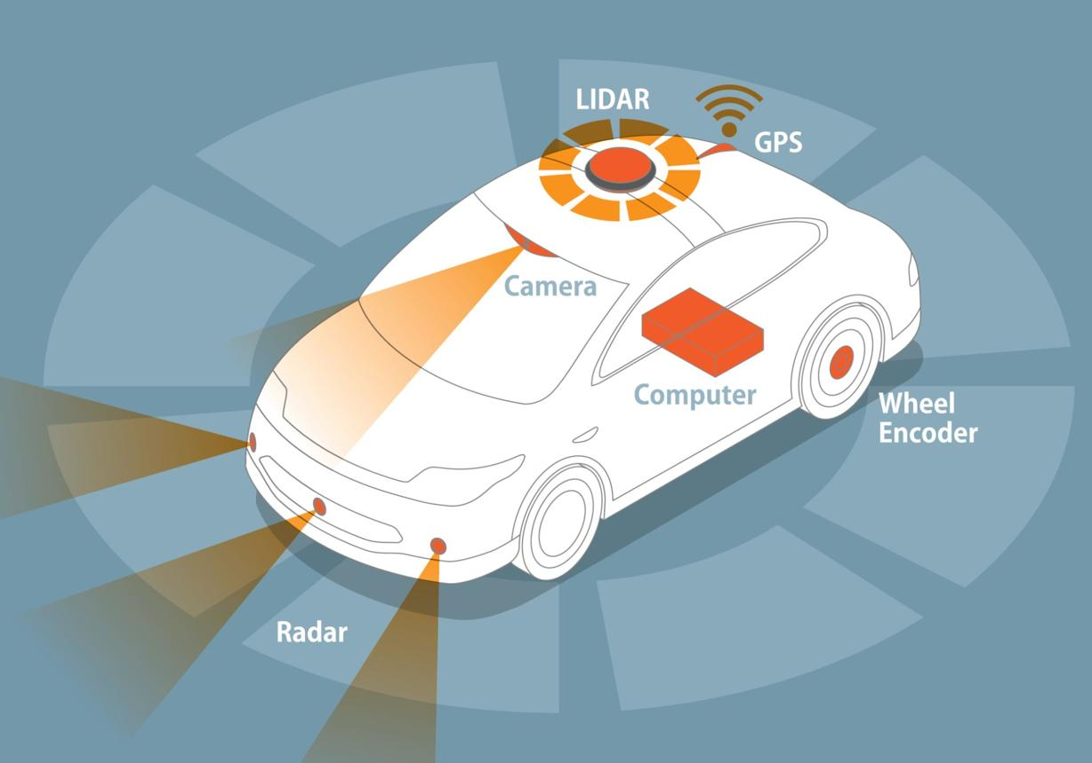

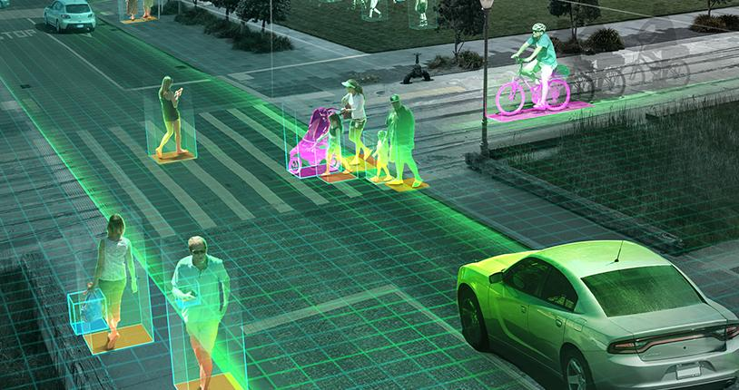
5
Self-driving vehicles use AI to understand their surroundings and make driving decisions.
The vehicle continuously processes information from:
- Cameras
- GPS
- Radar
- LiDAR Sensors
The AI system identifies:
- Roads
- Traffic signals
- Pedestrians
- Vehicles
and decides how the car should move safely.

Example
When a pedestrian suddenly crosses the road, the AI detects the obstacle and applies the brakes automatically.

3.3 Recommendation Systems
Recommendation systems suggest products, movies, songs, or content based on user preferences.

Examples
- Netflix recommending movies
- YouTube suggesting videos
- Amazon suggesting products
- Spotify recommending music
These systems analyze:
- User behavior
- Viewing history
- Purchases
- Similar users' interests

Real-World Scenario
If you watch several videos about web development, YouTube's AI learns your interests and recommends more programming-related content.

3.4 Face Recognition
Face recognition systems use computer vision and deep learning to identify individuals from images or videos.

Applications
- Smartphone Face Unlock
- Attendance Systems
- Airport Security
- Law Enforcement

Example
When you unlock your phone using Face ID, AI compares your face with the stored facial data and verifies your identity within seconds.

3.5 Medical Diagnosis


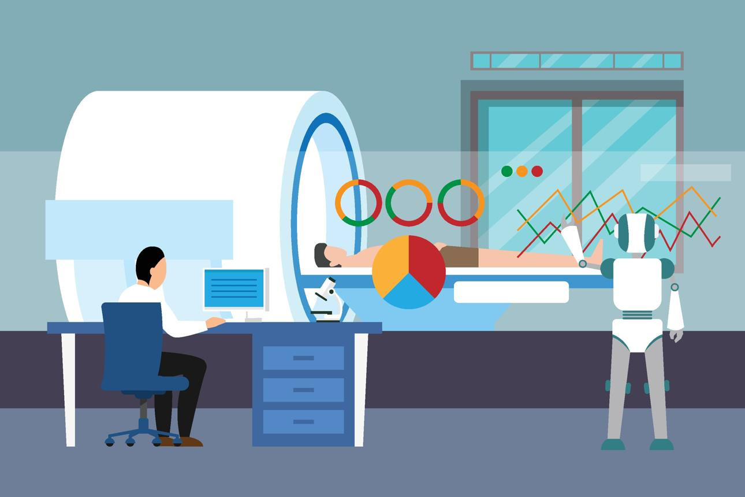
5
Healthcare organizations use AI to assist doctors in diagnosing diseases more accurately and quickly.
AI can analyze:
- X-rays
- MRI Scans
- Blood Reports
- Patient Records

Example
An AI system can examine thousands of medical images and detect signs of cancer that may be difficult for humans to identify early.

Benefits
- Faster diagnosis
- Better treatment planning
- Reduced human error

3.6 Fraud Detection
Banks and financial institutions use AI to detect unusual activities and prevent fraud.

Example
Suppose your bank account normally makes purchases in Chennai.
Suddenly, a large transaction is attempted from another country.
The AI system identifies this as suspicious and may:
- Block the transaction
- Send an alert
- Request additional verification
This helps protect customers from financial fraud.

4. Types of Artificial Intelligence

Narrow AI (Weak AI)

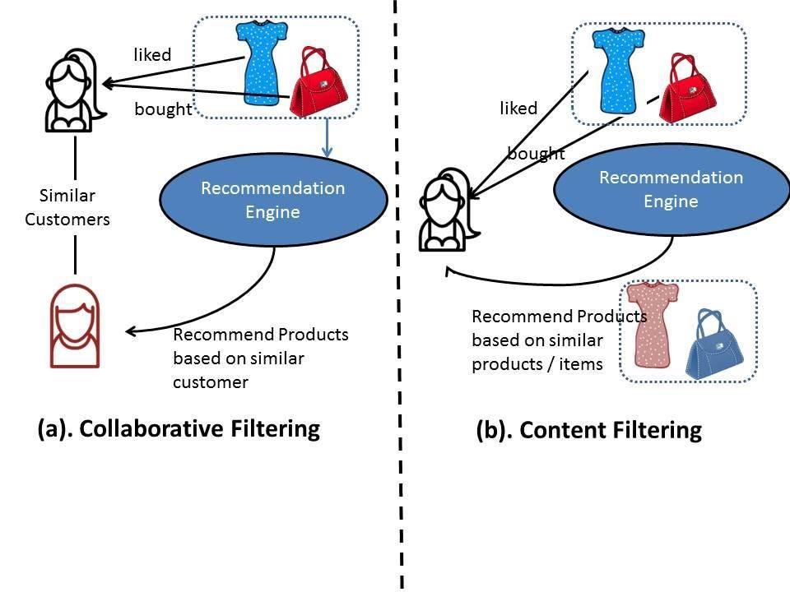
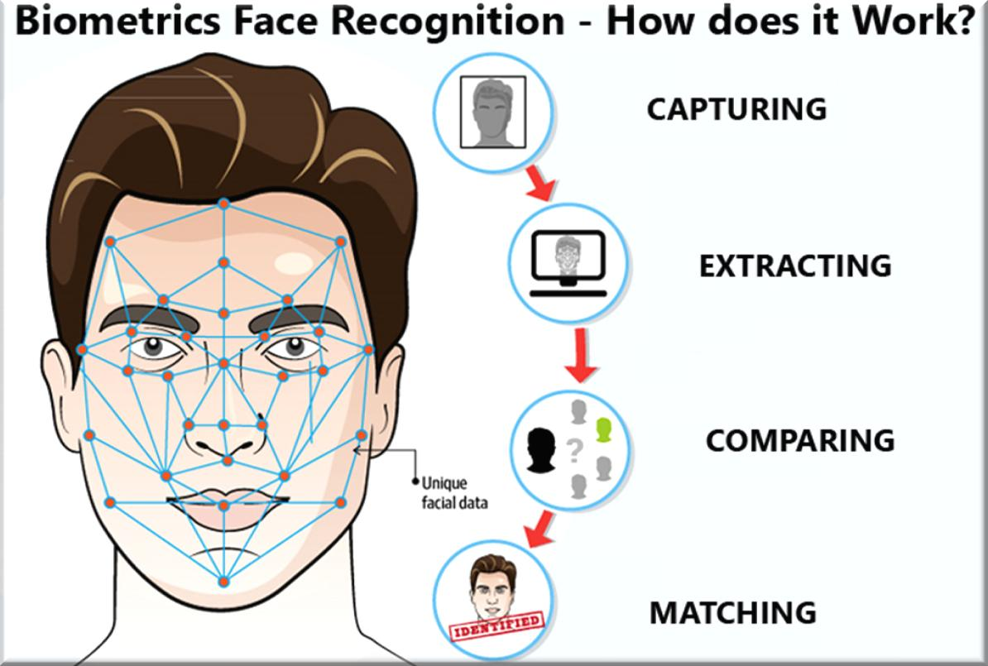
5
Narrow AI is designed to perform specific tasks.
It excels at one job but cannot perform tasks outside its training.

Examples
- ChatGPT
- Siri
- Google Translate
- Face Recognition Systems

Characteristics
- Task-specific
- Most AI systems today belong to this category
- Cannot think like humans

General AI (Strong AI)
General AI refers to machines that can perform any intellectual task that a human can perform.
Such systems would be capable of:
- Learning new skills
- Reasoning independently
- Understanding context
- Solving unfamiliar problems

Current Status
General AI does not yet exist.
It remains a major research goal in the AI community.

Example
Imagine a robot that can:
- Drive a car
- Teach mathematics
- Write software
- Cook food
without requiring separate programming for each task.
That would be General AI.

Super AI
Super AI is a hypothetical form of intelligence that surpasses human intelligence in every area.
It would outperform humans in:
- Scientific research
- Creativity
- Problem-solving
- Decision-making

Current Status
Super AI is purely theoretical and does not exist today.
It is commonly discussed in research, ethics, and science fiction.

Comparison of AI Types
Feature | Narrow AI | General AI | Super AI
Exists Today | Yes | No | No
Task Specific | Yes | No | No
Human-Level Intelligence | No | Yes | Beyond Human
Example | ChatGPT | Not Yet Created | Theoretical

Practical Activity

Activity: Identify AI Around You
Create a table containing 10 AI-powered applications that you use daily.
Application | AI Feature
YouTube | Video Recommendation
Google Maps | Route Optimization
ChatGPT | Conversational AI

Assessment

Part A – Multiple Choice Questions

1. What is the primary goal of Artificial Intelligence?
a) Store data efficiently
b) Simulate human intelligence
c) Increase internet speed
d) Improve computer hardware
Answer: b

2. Which of the following is an example of Narrow AI?
a) Human Brain
b) Super AI
c) ChatGPT
d) General AI
Answer: c

3. Which industry uses AI for fraud detection?
a) Agriculture
b) Banking
c) Construction
d) Manufacturing
Answer: b

4. Face Unlock in smartphones uses:
a) Blockchain
b) Cloud Computing
c) Face Recognition
d) Networking
Answer: c

5. Which type of AI currently does not exist?
a) Narrow AI
b) Recommendation AI
c) General AI
d) Chatbots
Answer: c

